Tessere Spezier Raboso IGT

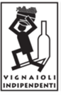

***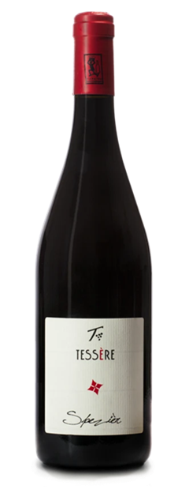

|  |  |
| --- | --- |
| ***Grape Variety*** | 100% Raboso Piave |
| ***Vineyard Location*** | Noventa di Piave (Venice), Veneto |
| ***Soil*** | Clay rich in salts and limestone deposits |
| ***Training System*** | Guyot |
| ***Vine Density*** | 5,100 / 6,300 vines per hectare |
| ***Yield Per Hectare*** | 7,600/10,000 kg. per hectare, depending on vintage |
| ***Vineyard Size*** | 15 hectares |
| ***Annual Production*** | 10,000 bottles / year |
| ***Harvest*** | Hand harvested end October |
| ***Vinification*** | Stainless steel fermented and rested. Fermentation occurs naturally with indigenous yeast |
| ***Aging*** | In bottles for at least 3 years |
|  |  |
| ***Alcohol Vol*** | 12.5% |
| ***Color*** | Intense ruby red moving to garnet with aging |
| ***Aroma*** | Scents of geranium, violet (potpourri), licorice,  bark, black pepper, wild cherries.  spices are really evident here |
| ***Taste*** | Typical high acidity and firm rough tannins |
| ***Food Pairing*** | Wild game, eel, fried and stewed fish,  red meat also grilled or roasted, cold cuts,  aged cheese or the local "pasta and beans" |
| ***Serving Temperature*** | 18° C / 64° F |
| ***Type Of Cork*** | Natural Cork |
| ***Bottle Size (L)*** | 0.75 |