Tessere Redentor Raboso Rosato Vino Spumante Brut Metodo Classico

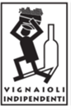

***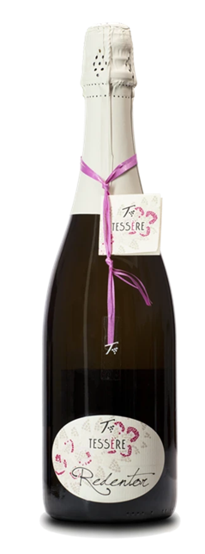

|  |  |
| --- | --- |
| ***Grape Variety*** | 100% Raboso Piave, vinified in Rosé |
| ***Vineyard Location*** | Noventa di Piave (Venice), Veneto |
| ***Soil*** | Silty clay with calcareous caranto bedrock |
| ***Training System*** | Guyot |
| ***Vine Density*** | 5,100 / 6,300 vines per hectare |
| ***Yield Per Hectare*** | 7,600/10,000 kg. per hectare, depending on vintage |
| ***Vineyard Size*** | 15 hectares |
| ***Annual Production*** | 5,000 bottles / year |
| ***Harvest*** | Hand harvested end October |
| ***Vinification*** | Stainless steel fermented and rested. Fermentation occurs naturally with indigenous yeast |
| ***Aging*** | In bottles for at least 5 years |
| ***Organic Certifications*** | EU certified organic since 2012 |
| ***Alcohol Vol*** | 12.5% |
| ***Perlage*** | Thin and persistent Perlage |
| ***Color*** | Pale straw yellow with green reflections |
| ***Aroma*** | Steely nose with some grenadine,  a basket of citrus fruit: grapefruit,  blood orange, bergamot |
| ***Taste*** | Fairly acidulous, lively, complex |
| ***Food Pairing*** | Excellent as aperitif, well suitable also  for main courses, poultry, and seafood,  like salmon, mixed vegetables |
| ***Serving Temperature*** | 10° C / 50° F |
| ***Type Of Cork*** | Sparkling wine cork with cage |
| ***Bottle Size (L)*** | 0.75 |