Vigne Del Bosco

Prosecco Extra Dry Millesimato DOC

***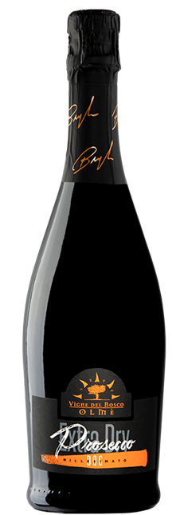

|  |  |
| --- | --- |
| ***Grape Variety*** | 100% Glera |
| ***Vineyard Location*** | Ceggia (Venice), Veneto |
| ***Soil*** | Silty clay with calcareous caranto bedrock |
| ***Training System*** | Sylvoz |
| ***Vine Density*** | 2,700 vines per hectare |
| ***Yield Per Hectare*** | 12,000 / 14,000 kg. per hectare, depending on vintage |
| ***Vineyard Size*** | 10 hectares |
| ***Annual Production*** | 15,000 bottles / year |
| ***Harvest*** | Hand harvested; the grapes must be not too ripe |
| ***Vinification*** | Grapes are destemmed and crushed, must clarification, long temperature-controlled fermentation at 15°C. Charmat sparkling process |
| ***Aging*** | resting in the bottle before sale for 20 days |
| ***Alcohol Vol*** | 11.5% |
| ***Perlage*** | Thin and persistent Perlage |
| ***Color*** | Pale straw yellow with greenish reflections |
| ***Aroma*** | Green apple, hints of acacia flowers and wisteria |
| ***Taste*** | Fresh, dry, persistent flavor, lean and flavorful body |
| ***Food Pairing*** | Excellent on any occasion, especially as an aperitif,  but also, for the whole meal |
| ***Serving Temperature*** | 6-7 °C / 43-45°F |
| ***Type Of Cork*** | Sparkling wine cork with cage |
| ***Bottle Size (L)*** | 0.75 |