Tessere Galion Merlot IGT

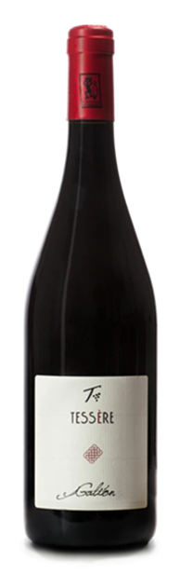

|  |  |
| --- | --- |
| ***Grape Variety*** | 100% Merlot |
| ***Vineyard Location*** | Noventa di Piave (Venice), Veneto |
| ***Soil*** | Clay rich in salts and limestone deposits |
| ***Training System*** | Spurred cordon |
| ***Vine Density*** | 5,800 vines per hectare |
| ***Yield Per Hectare*** | 8,700 kg. per hectare |
| ***Vineyard Size*** | 15 hectares |
| ***Annual Production*** | 12,000 bottles / year |
| ***Harvest*** | Hard harvested end September |
| ***Vinification*** | Stainless steel fermented and rested. Fermentation occurs naturally with indigenous yeast |
| ***Aging*** | In bottles for at least 1 yeast |
| ***Organic Certifications*** | EU certified organic since 2012 |
| ***Alcohol Vol*** | 13.0% |
| ***Color*** | Deep ruby red |
| ***Aroma*** | Intense fruitiness, balsamic |
| ***Taste*** | Dry, flavorful, and full-bodied |
| ***Food Pairing*** | Wild game, eel, fried and stewed fish,  red meat also grilled or roasted, cold cuts,  aged cheese or the local "pasta and beans" |
| ***Serving Temperature*** | 18° C / 64° F |
| ***Type Of Cork*** | Natural Cork |
| ***Bottle Size (L)*** | 0.75 |