Vigne Del Bosco

Chardonnay Veneto Frizzante IGT

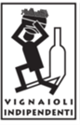

***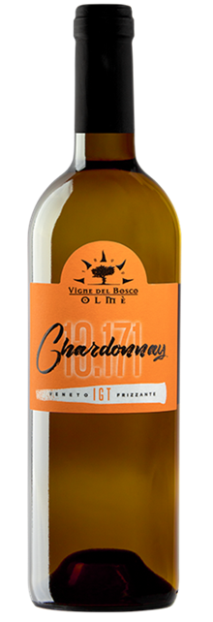

|  |  |
| --- | --- |
| ***Grape Variety*** | 100% Chardonnay |
| ***Vineyard Location*** | Ceggia (Venice) |
| ***Soil*** | Clay rich in salts and limestone deposits |
| ***Training System*** | Sylvoz |
| ***Vine Density*** | 2,700 vines per hectare |
| ***Yield Per Hectare*** | 8,000 / 9,000 kg. per hectare, depending on vintage |
| ***Vineyard Size*** | 10 hectares |
| ***Annual Production*** | 10,000 bottles / year |
| ***Harvest*** | On the third decade of August, rigorously manual, not looking for overripe grapes |
| ***Vinification*** | Grapes are destemmed and cooled immediately, quick soft pressing of the grapes, must clarification, low temperature controlled fermentation. Tank method sparkling process |
| ***Aging*** | Released after bottling |
| ***Alcohol Vol*** | 12.0% |
| ***Perlage*** | light mousse |
| ***Color*** | Straw yellow |
| ***Aroma*** | Persistent and fruity Golden apple scent,  floral almond blossom |
| ***Taste*** | Fresh, fruity, soft, and balanced |
| ***Food Pairing*** | Ideal in aperitifs or appetizers with  fish and seafood |
| ***Serving Temperature*** | 8-10° C / 46-50° F |
| ***Type Of Cork*** | Technical stopper (compressed cork powder) |
| ***Bottle Size (L)*** | 0.75 |