Tessere Alimante Chardonnay 2018

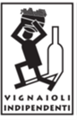

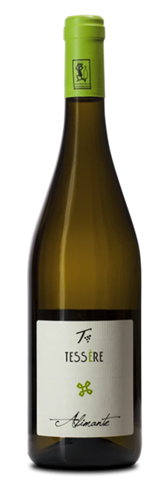

|  |  |
| --- | --- |
| ***Grape Variety*** | 100% Chardonnay |
| ***Vineyard Location*** | Noventa di Piave (Venice), Veneto |
| ***Soil*** | Clay rich in salts and limestone deposits |
| ***Training System*** | Guyot |
| ***Vine Density*** | 6,300 vines per hectare |
| ***Yield Per Hectare*** | 9,500 kg. per hectare, depending on vintage. |
| ***Vineyard Size*** | 15 hectares |
| ***Annual Production*** | 5,000 bottles / year |
| ***Harvest*** | Hard harvested end September |
| ***Vinification*** | Stainless steel fermented and rested. Fermentation occurs naturally with indigenous yeast |
| ***Aging*** | Maturation on fine lees for at least six months. In bottles for at least 1 year |
| ***Organic Certifications*** | EU certified organic since 2012 |
| ***Alcohol Vol*** | 14% |
| ***Color*** | Straw yellow |
| ***Aroma*** | Floral, fruity, mineral bouquet |
| ***Taste*** | Dry, flavorful, and elegant taste |
| ***Food Pairing*** | Appetizers, pasta and rice dishes, poultry  fish and seafood, vegetables,  cheeses, and pizza |
| ***Serving Temperature*** | 12° C / 54° F |
| ***Type Of Cork*** | Natural Cork |
| ***Bottle Size (L)*** | 0.75 |